

**COMPUTER SCIENCEPROJECT**

**CAR BOOKING SYSTEM**

**EMIRATES**

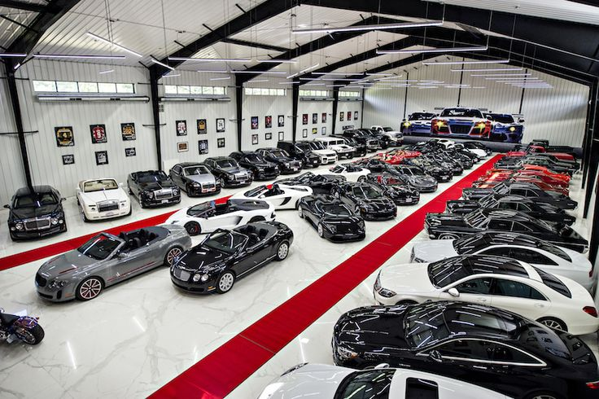

Submitted by

JEBEZ OSWALD .K

XII – G

Reg.No :



**CERTIFICATE**

**COMPUTER SCIENCE**

Certified to be the bonafide project work done by **JEBEZ OSWALD. K**

of Class **XII** Section **G** in Pushpalata Vidya Mandir, Tirunelveli-11 during the academic year 2022-2023.

Signature of Principal Signature of Teacher

School Seal

Submitted for Senior School Certificate Practical Examination held in **COMPUTER SCIENCE** at ***Pushpalata Vidya Mandir Senior Secondary School, Tirunelveli.***

Date :

Internal Examiner External Examiner

**ACKNOWLEDGEMENT**

I wish to express my deep gratitude and sincere thanks to Senior Principal **Mrs. PUSHPAVENI AYYAPPAN** for her encouragement and facilities that she provided for this project work. I sincerely appreciate this magnanimity by taking me into her fold for which I shall remain indebted to her.

I extend my hearty thanks to my Computer Science teacher Ms. Hannah who guided me to the successful completion of this project.

I take this opportunity to express my deep sense of gratitude for their invaluable guidance, constant encouragement, constructive comments, sympathetic attitude and immense motivation, which has sustained my efforts at all stages of this project work.

**INDEX**

|  |  |  |
| --- | --- | --- |
| **S.NO** | **TITLE** | **PAGE.NO** |
| 1 | Description | 05 |
| 2 | Source Code | 08 |
| 3 | Output | 158 |